SYSTEM DESIGN

1. ARCHITECTURE DIAGRAM

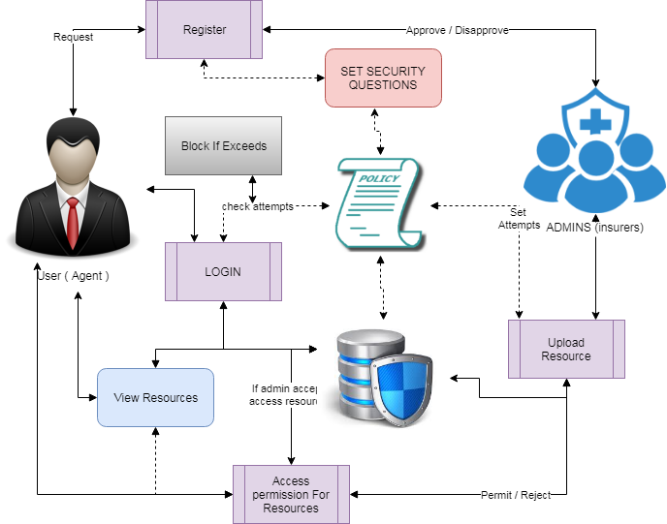

1. COMPONENT DIAGRAM
   1. User

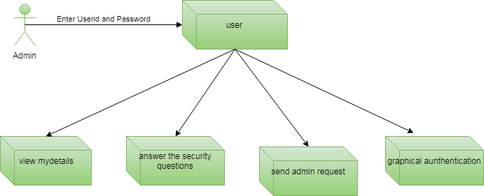

* 1. Admin

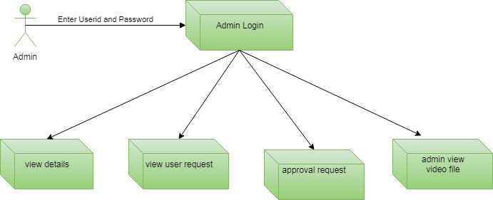

1. ER DIAGRAM
   1. User

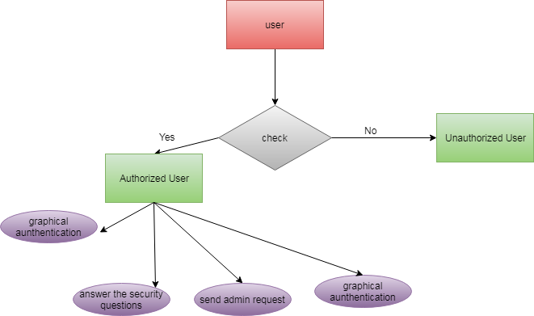

* 1. Admin

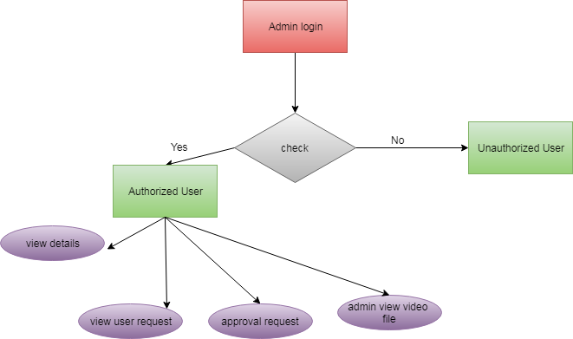

1. USE CASE DIAGRAM
   1. User



* 1. Admin



1. CLASS DIAGRAM

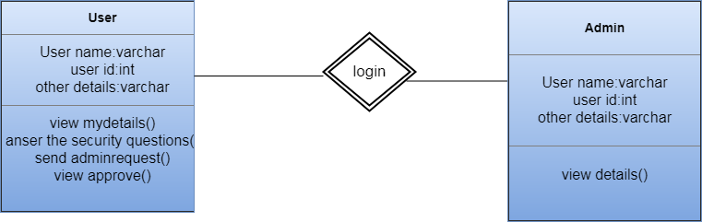

1. DATA FLOW DIAGRAM
   1. User

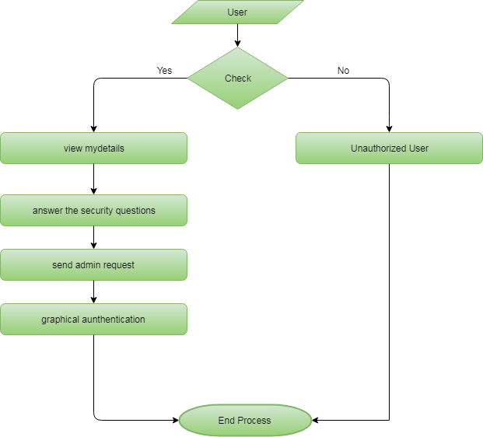

* 1. Admin

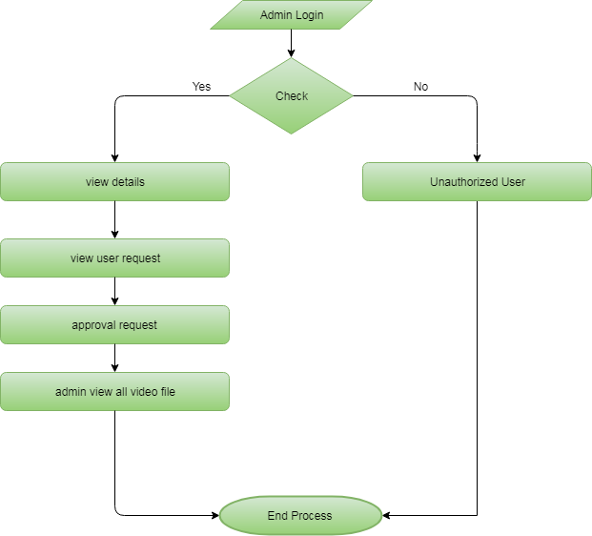

1. ACTIVITY DIAGRAM
   1. User

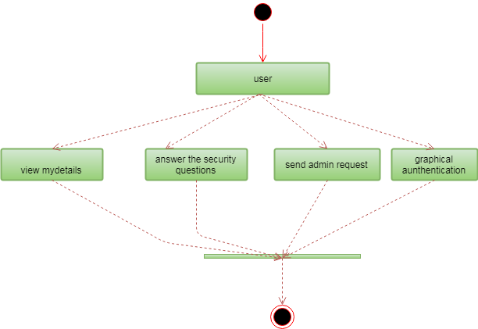

* 1. Admin

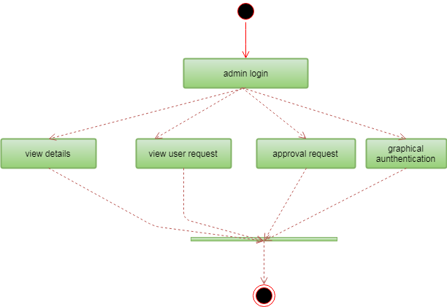

1. SEQUENCE DIAGRAM
   1. User

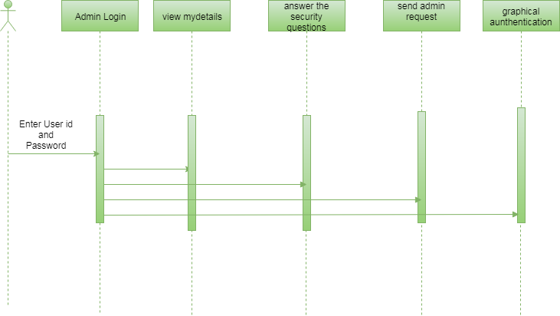

* 1. Admin

